**Retractable supporting structure failure**

**insight:**

The design intends to dig a row and then pick up the potato being exposed to the air under the TsTsians’ physical constraint. During the group discussion, three steps are established to achieve the goal. First, a retractable mechanism is needed to create a strong force to penetrate the soil. Second, TsTsians need to apply a pulling force to move the tool toward themselves. In the end, the retractable mechanism should be able to collect the potato in the shovel into a bag.

In the low-fidelity prototype, our group decided to use a retractable umbrella instead of designing and manufacturing a moving part that links the shovel and the chassis. The testing data had shown that the force required to retract the umbrella increased significantly after two hours of testing in the Idea Clinic soil pit. The unusual data made our group perform root-cause analysis on the prototype. After disassembling the mechanical structure and inspecting each component, our group discover that the retractable component had bent significantly. Therefore, during the analysis meeting, our group concluded that the bent is caused by the continuous collision between the shovel and the ground while the force is being transferred to the umbrella and causes the bent. However, the umbrella is not strong enough to support the big shovel and the collision.

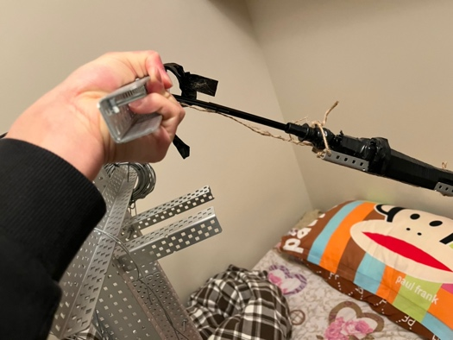 figure 0.1. significantly bent umbrella

**Evidence:**

1. Without changing the design, the first testing only requires 32N of force to fully retract the shovel and the umbrella. But at the end of the testing, the force requires to do the same action is 48N. (Nov 17th testing data)

2. The umbrella retractable components are bent significantly, and the metal is compressed due to the bent.

**Recommend actions:**

**For revision 1(the first prototype):**

* Remove the retractable feature and design a new solution to penetrate the soil.
* Reduce the amount of expectation
* Add aluminum frames to support the original structure.

**For future iteration:**

* Change the shovel to a smaller one
* Design a new version of the retractable mechanism.
* Using a motor to reduce the amount of force required to retract.

**Technical Engineering contribution**

**Nature of contribution**

Engineering is a discipline that requires qualified engineers to apply their knowledge to real-world applications. Similar to scientists, engineers are also willing to obtain new knowledge. Engineers and scientists both understand and believe that everything can be improved.[1] In contrast, instead of having theories nicely laid on paper, engineers focus more on bringing thoughts into real life. As system design engineers, innovative thinking is applied to the design processes to create unique and vivid solutions to real-world problems. Building upon the understanding that nothing is perfect, engineers release the product in the title of revision version. Every time, engineers learn from their mistakes and improve the current design to achieve a better one in the next iteration. On the other hand, all engineers are forced to follow a set of rules and standards, which are developed under the careful analysis of experience and accidents. When engineers give interpretations and credits to the topic that they are specialized in, they must be responsible for all the words and decisions they’ve made.[2] As a result, undergraduates need to pass the qualification tests before they can be called engineers. [3] Moreover, systems included a handful of interconnections and elements,[1] system design engineers should be more focused on analyzing the overall architecture and give useful feedback based on the analysis tools engineers have learned, for instance, system diagrams, etc.

**Impact on prototyping**

My contribution to the group is the chassis and part of the digging mechanism. As mentioned in the first section, the design intention is to create a machine that can dig a row in the field and then harvest the potato. Therefore, this requires the design to include moving parts that can reduce the force TsTsians required to drag the whole machine backward. Undergraduates are not real engineers; as a result, the design I proposed is based on other successful products in the market. The product learned from others' designs and added new implementations that can help to solve the current issue. The most used chassis in the industry is the four-wheel robot chassis, as shown in figure1.

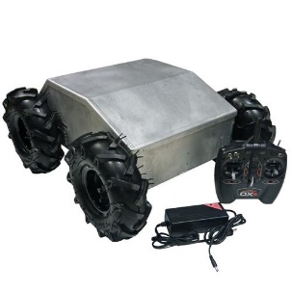

figure 1. hobbyist and industrial robot chassis design  
However, this design has a weakness in that the chassis is not capable of moving from one row to the other under a limited amount of space and force. That is to say, it is very hard to only use pulling force to change the position and the heading of the robot. Therefore, personal investigations are made to improve the usability of the chassis for users with only pulling force. The solution proposed is to replace the original wheel with a set of omnidirectional wheels, as shown in figure 2.

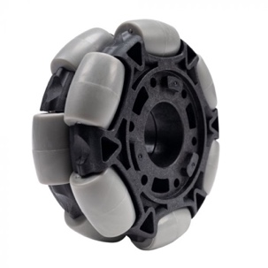figure 2. The omnidirectional wheel used in robotics to limit movement area

The sub-wheels on the large wheel give the chassis the ability to move in the y-direction while still being able to move in the x-direction. The new chassis is able to move in both the x and y direction with only the pulling force, which proves the design of the chassis is a success. Moreover, positive feedback is received when inviting classmates to test the two different types of chassis. The tests have shown that it is almost impossible to move the original chassis to a new row only using the pulling force, however, the new chassis only require a reorientation of the user position and can easily move the chassis from one row to another. Furthermore, 1.0-meter handlers are provided to help TsTsians to apply the pulling force onto the chassis.

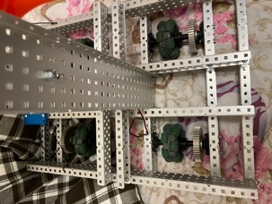figure 3. **The chassis used in the rev 1 prototyping.**

**Reference**

[1] Dr. Matt Borland, “What is system design engineering”. SYDE 161. <https://learn.uwaterloo.ca/d2l/le/content/841435/viewContent/4574702/View>

[2] “Code of ethics,” *Code of Ethics | National Society of Professional Engineers*. [Online]. Available: https://www.nspe.org/resources/ethics/code-ethics. [Accessed: 06-Dec-2022].

[3] “Examination syllabi,” *Engineers Canada*. [Online]. Available: https://engineerscanada.ca/become-an-engineer/examination-syllabi. [Accessed: 06-Dec-2022].

*Figure [1] Configurable - IG52-DB4-E, 4WD All Terrain Heavy Duty Enclosed Robot Platform*. [Online]. Available: https://www.superdroidrobots.com/store/robotic-kits-platforms/wheeled-robots/product=2386. [Accessed: 06-Dec-2022].

Figure [2] “Omni-directional wheels,” *VEX Robotics*. [Online]. Available: https://www.vexrobotics.com/omni-wheels.html?___store=vexroboticsca&___from_store=vexrobotics. [Accessed: 06-Dec-2022].

|  |  |  |
| --- | --- | --- |
| Testing subject | The first test | The end test |
| Force required | 32 | 48 |
| Self-weight | 3.42 | 4.94(stabilize the design) |